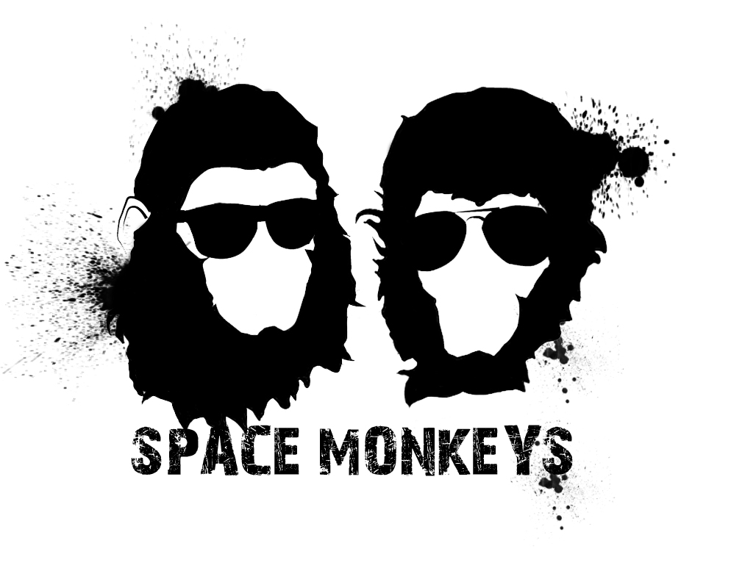
SPACE MONKEYS is a talented director duo with astonishing versatility. Whether it´s directing actors, creating an aesthetic piece or shooting spots that require VFX integrated with live footage. It´s been recently discovered that they were born in Venezuela and Spain but at a young age decided to travel the galaxy. And like good intergalactic travelers, Robert and David have an amazing knack for all things technology mixed with a profound sense of beauty and artistry. They´ve worked with agencies like LOLA (Lowe Madrid), Del Campo Saatchi & Saatchi , Ogilvy & Mather, McCann Erickson, Darwin & Co, Germinal, D6 or La Despensa, and for brands like Toyota, Ford, Orange, Burger King, Mattel, Red Cross, Coca Cola, LlaoLlao, History Channel or Red Bull.

